Name: A.Reddy Sulochana
Reg.No: 192372730

Exp.No.04 Crypt Arithmetic Problem
01.08.26

Aim:
To implement the Crypt Arithmetic Problem in Python and find the solution by assigning digits to letters such that the arithmetic equation is satisfied.
Algorithm:
- Start the program.
- Read the three words (operand1, operand2, and result).
- Generate all possible digit assignments to the unique letters.
- Ensure that no two letters are assigned the same digit.
- Check that the first letter of each word is not assigned zero.
- Convert the words into numbers using the assigned digits.
- Verify whether the arithmetic equation is satisfied.
- If satisfied, display the solution.
- Stop the program.

Program:
from itertools import permutations
word1 = input("Enter first word: ").upper()
word2 = input("Enter second word: ").upper()
result = input("Enter result word: ").upper()
letters = list(set(word1 + word2 + result))
if len(letters) > 10:
print("Too many unique letters!")
exit()
for p in permutations("0123456789", len(letters)):
d = dict(zip(letters, p))
if d[word1[0]] == '0' or d[word2[0]] == '0' or d[result[0]] == '0':
continue
n1 = int("".join(d[ch] for ch in word1))
n2 = int("".join(d[ch] for ch in word2))
n3 = int("".join(d[ch] for ch in result))
if n1 + n2 == n3:
print("Solution Found")
print(word1, "=", n1)
print(word2, "=", n2)
print(result, "=", n3)
break
else:
print("No solution found")

Input:
Enter first word: SEND
Enter second word: MORE
Enter result word: MONEY

Output:
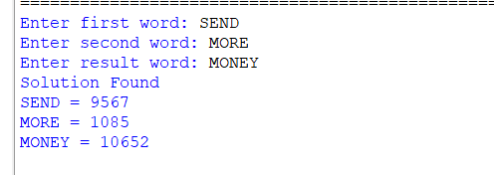

Result:
Thus, the Python program to solve the Crypt Arithmetic Problem (SEND + MORE = MONEY) was executed successfully, and the correct digit assignment satisfying the equation was obtained.

